Section-A

- a) Define engineering economies. (3)

Solve: Engineering economics is like a money coach for engineers! It helps them pick the best solution by comparing the cost and benefits, like choosing a new tool: one might cost less, but the other saves time, making it worth the extra money in the long run. It's basically all about making smart choices with money in engineering!

b) Discuss the role of engineering economics in decision making by engineers on the job, with example. (4)

Solve: Engineering economics is like a trusty accountant for engineers! It helps them weigh the costs and benefits of different choices, making sure projects are financially sound.

For example: An engineer choosing between two machines for a factory. One is cheaper but needs frequent repairs, while the other is expensive but lasts longer. Engineering economics gives them tools, like comparing their life cycle costs, to pick the most cost-effective option. This saves the company money and ensures the project succeeds. So, engineering economics helps engineers make smart decisions that benefit everyone!

c) Distinguish between Simple and compound interest rates. (3)

Solve:
Simple Interest:
- Calculated only on initial principal.
- Fixed amount earned regardless of loan duration.
- Think of a flat rate on a phone bill.

Compound Interest:
- "Interest on interest" - earns on both principal and accrued interest.
- Grows exponentially over time.
- Imagine a snowball effect - bigger returns the longer it grows.

Key difference: Compound interest is like a self-multiplying investment, while simple interest is a one-time charge

- a) Explain the concept of arithmetic gradient with figures. (5)

Solve:

An arithmetic gradient series means the cash we get or spend changes by the same amount each time. This change is called the gradient.
Unlike other series where we get different amount of changes every time but with an arithmetic gradient series, we can see the same amount of cash changing each time. To make it simpler here’s an example, if we buy a used car with a 1-year warranty, the base cost might be $2500 including the initial things like gasoline and insurance. After the first year, we start paying for repairs, which go up by $200 each year. So, the second year is $2700, the third year is $2900, and so on until year 'n,' when it's $2500 + (n - 1) * $200. The base amount ($2500 in year 1) is different from the changing amount ($200), simplifying analysis.

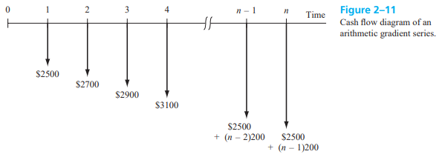

b) A coal-fired power plant has upgraded all emission control value. The modification costs only $8000 and is expected to last 6 years with a $200 salvage value. The maintenance cost is expected to be high at $1700 the first year, increasing by 11% per year thereafter. Determine the equivalent present worth of the modification and maintenance cost at 8%. (5)
Solve: 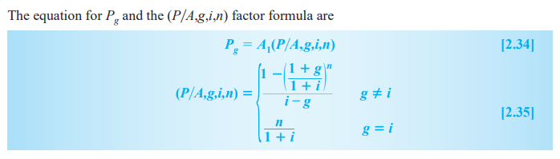
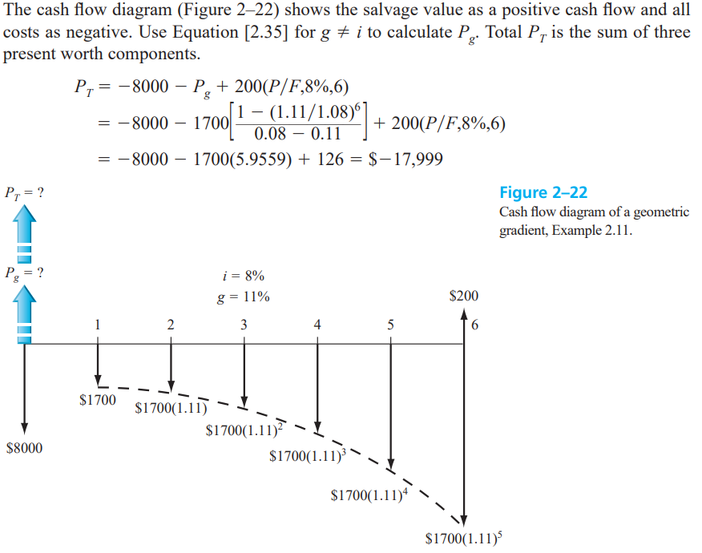
- a) Distinguish between nominal interest rate and effective interest rate (3)

Solve:
Nominal Rate:
- Stated rate, like a sticker price.
- Ignores compounding, like a flat fee.
- Useful for quick comparisons, but not the full picture.

Effective Rate:
- Hidden cost, like the final price after discounts.
- Considers compounding, like snowballing interest.
- More accurate for real-world calculations.

Key difference: Nominal is the advertised number, while effective is the true cost with compounding.

b) Three different bank loan rates for electric generation equipment are listed below. Determine the effective rate on the basis of the compounding period for each rate.
- 9% per year, compounded quarterly
- 9% per year, compounded monthly,
- 4.5% per 6 months, compounded weekly (5)

Solve:
Nominal r% Per t | Compounding  Period (CP) | Compounding  Frequency (m) | Effective Rate Per  CP (r/m)
- 9% per year | Quarter | 4 | 2.25%
- 9% per year | Month | 12 | 0.75%
- 4.5% per 6 month | Week | 26 | 0.173%

Note: Compound frequency,
1 year = 52 weeks
i.e., 6 months = 52/2 = 26 weeks

c) What is effective annual interest rate? (2)

Solve: The effective annual interest rate (EAR) is the total cost of borrowing money for a year. It considers both the stated interest rate and how often the interest is added to the initial amount. The EAR gives a more accurate picture of the actual yearly cost compared to just looking at the stated interest rate

Section-B
- a) What do you mean by inflation? What are the causes of inflation? (3)
Solve:

Inflation is such a situation when too much money chases too few goods

Causes of Inflation:
Demand-Pull: When many people want to buy things, but there aren't enough things available, prices go up.
Cost-Push: If it becomes more expensive to make things like if the cost of materials or labor goes up, then the prices of those things increase.
Built-In Inflation: When workers ask for higher wages, companies might increase prices to pay them, making everything more expensive.
Monetary Policy: Sometimes, when governments print more money, it can lead to inflation because more money is chasing the same amount of goods, making prices rise.

b). Distinguish between demand pull and cost push inflation. (4)
Solve:

Demand-Pull Inflation: This happens when many people want to buy things, but there aren't enough things available to buy. For example everyone wanting the same product in the market and since there aren't many of the same product then the price goes up and it is called demand pull inflation.
Cost-Push Inflation: This occurs when it becomes more expensive to make things. For example, if the cost of materials or workers' wages increases, making stuff becomes pricier, and those higher costs can lead to higher prices for goods and services.

c). What annual deposit is required for 5 years to accumulate an amount of money with the same purchasing power as $680.58 today, if the market interest rate is 10% per year and inflation is 8% per year. (3)

Solve: 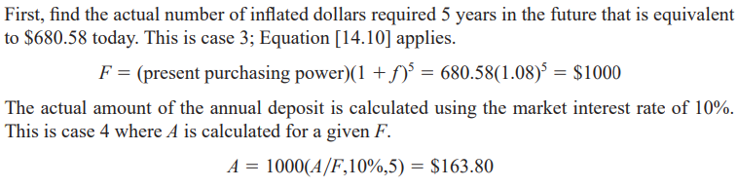

- a) What is the primary purpose of public sector project? (2)
Solve: The primary purpose of a public sector project is to benefit the community or the public. These projects are funded and managed by the government to provide services or infrastructure that improve people's lives, such as building schools, hospitals, roads, or parks.

b) Explain the fundamental difference between public projects and private project. (4)
Solve:

Public Projects:
Ownership: Run and owned by the government.
Purpose: Aimed at serving the public and community needs, such as infrastructure development (schools, roads, parks).
Funding: Financed by taxpayers through government budgets.

Private Projects:
Ownership: Executed by businesses or individuals.
Purpose: Geared towards making a profit, producing goods or services for the market.
Funding: Supported by private investors, loans, or company revenue.

In essence, public projects focus on societal benefits and are funded by public resources, while private projects aim for profitability and rely on private funding mechanisms.

c) Describe the procedure for incremental benefit cost (B/C) analysis of multiple alternatives (4)
Solve:
Incremental Benefit-Cost Analysis for multiple alternatives involves comparing the additional benefits and costs of each option compared to a baseline or reference alternative. Here's a simplified procedure:

1. Start with a Baseline: Identify the current situation as your baseline.
2. List Alternatives: Make a list of different options or projects.
3. Calculate Extra Benefits and Costs: Determine the additional benefits and costs for each alternative compared to the baseline.
4. Calculate B/C Ratio: Divide the incremental benefits by the incremental costs for each alternative.
5. Compare and Choose: Select the alternative with the highest Benefit-Cost (B/C) ratio, indicating the best balance of benefits and costs.

This approach helps in making informed decisions by considering the added benefits and costs of each alternative compared to a base scenario.

- a) Define value-added tax? How VAT is different from sales taxes and corporate taxes? (3)
Solve:
Value-Added Tax (VAT):
VAT is a tax collected at each step of a product's journey from production to consumption. It's based on the value added at each stage, and the consumer pays the final tax amount.

Difference from Sales Taxes:
Sales taxes are typically applied only at the final sale to the consumer. In contrast, VAT is a multi-stage tax, imposed at various points during the production and distribution process.

Difference from Corporate Taxes:
Corporate taxes focus on taxing a company's profits. In the case of VAT, while companies collect the tax, it is essentially a consumption tax. The burden of VAT is passed along the supply chain and, ultimately, it is the end consumer who bears the tax.

b) What is net cash flows (NCF)? (2)
Solve:

Net Cash Flows (NCF):
Net Cash Flows (NCF) is the total amount of money that comes in and goes out of a business or project. It's calculated by subtracting the total cash outflows (expenses) from the total cash inflows (revenues and other sources of cash). NCF shows the overall cash position, indicating whether a business is gaining or losing cash.

c) Tata motor is a major automobile manufacturing in India. The company buys products that fall under different sections of Indian Govt. VAT and tax code and therefore, the product have different VAT rates. In one particular accounting period Tata has invoices from four different suppliers of $1.5 million, $3.8 Million, $1.1 million and S9, 00,000. The products Tata purchased were subject to VAT rates of 4%, 4%, 12.5% and 22% respectively.

- How much total VAT did Tata pay to its vendors?
- Assume that Tata's products have a VAT rate of 12.5%. If Tata's sales during the period were $ 9.2 million, how much VAT did the Indian Treasury receive from
Tata? (5)
Solve: 